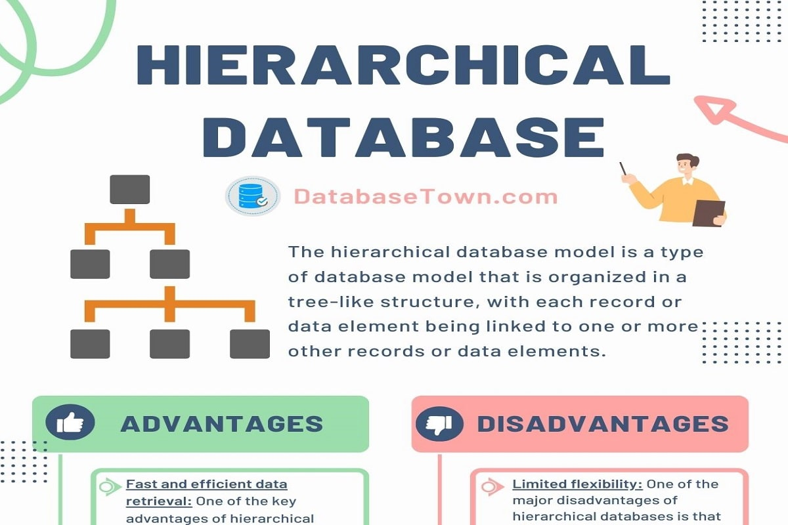
Hierarchical Database (Model, Advantages, Disadvantages)
May 20, 2024 by Zubair Akhtar
A hierarchical database is a type of database that is organized in a tree-like structure, with each record or data element being linked to one or more other records or data elements.
In a hierarchical database, data is stored in a parent-child relationship, with a parent record being linked to one or more child records. This type of database is commonly used to represent data relationships, such as those found in organizational charts or family trees.
Hierarchical Database Model
In a hierarchical database model, data is organized into a hierarchy of records, with the topmost record being the root of the hierarchy. Each record in the hierarchy can have one or more child records, which are linked to the parent record.
This allows for the representation of data relationships and the efficient retrieval of data. However, hierarchical database models are not as flexible as other database models, and are not well suited for handling complex data relationships or changes in data structures.
One of the key advantages of hierarchical databases is that they allow for fast and efficient data retrieval, since data is organized in a predictable and structured way. The hierarchical databases can be difficult to maintain and update, since changes to the data structure can impact the entire database.
History
The hierarchical structure was developed by IBM in the 1960s and used in early mainframe DBMS. Records’ relationships form a tree-like model.
This structure is simple but inflexible because the relationship is confined to a one-to-many relationship. The IBM Information Management System (IMS) and RDM Mobile are examples of hierarchical database systems with multiple hierarchies over the same data.
The hierarchical data model lost traction as Codd’s relational model became the de-facto standard used virtually by the all mainstream database management systems.
A relational-database implementation of a hierarchical model was first discussed in published form in 1992. Hierarchical data organization schemes resurfaced with the advent of XML in the late 1990s. The hierarchical structure is used primarily today for storing geographic information and file systems.
Hierarchical Database Advantages
- Fast and efficient data retrieval: One of the key advantages of hierarchical databases is that they allow for fast and efficient data retrieval, since data is organized in a predictable and structured way.
- Easy to add/delete information: In this type of database, you can easily add or delete the information.
- Predictable data structure: The hierarchical database model has a predictable and structured data structure, which makes it easier to understand and navigate.
- Efficient storage of data: Since hierarchical databases store data in a parent-child relationship, they can be more efficient in terms of storage compared to other database models.
- Good performance: Hierarchical databases can have good performance in terms of data retrieval and querying, especially for large datasets.
Hierarchical Database Disadvantages
- Limited flexibility: One of the major disadvantages of hierarchical databases is that they are not as flexible as other types of databases, and are not well suited for handling complex data relationships or changes in data structures.
- Difficult to maintain and update: Hierarchical databases can be difficult to maintain and update, since changes to the data structure can impact the entire database.
- Limited support for data manipulation: Hierarchical databases do not support complex data manipulation operations, such as data aggregation or data mining.
- Limited interoperability: Hierarchical databases are not compatible with other database models, which can limit their interoperability with other systems and applications.
- Lack of standardization: Since hierarchical databases are not as widely used as other database models, there is a lack of standardization and best practices for their use and management.
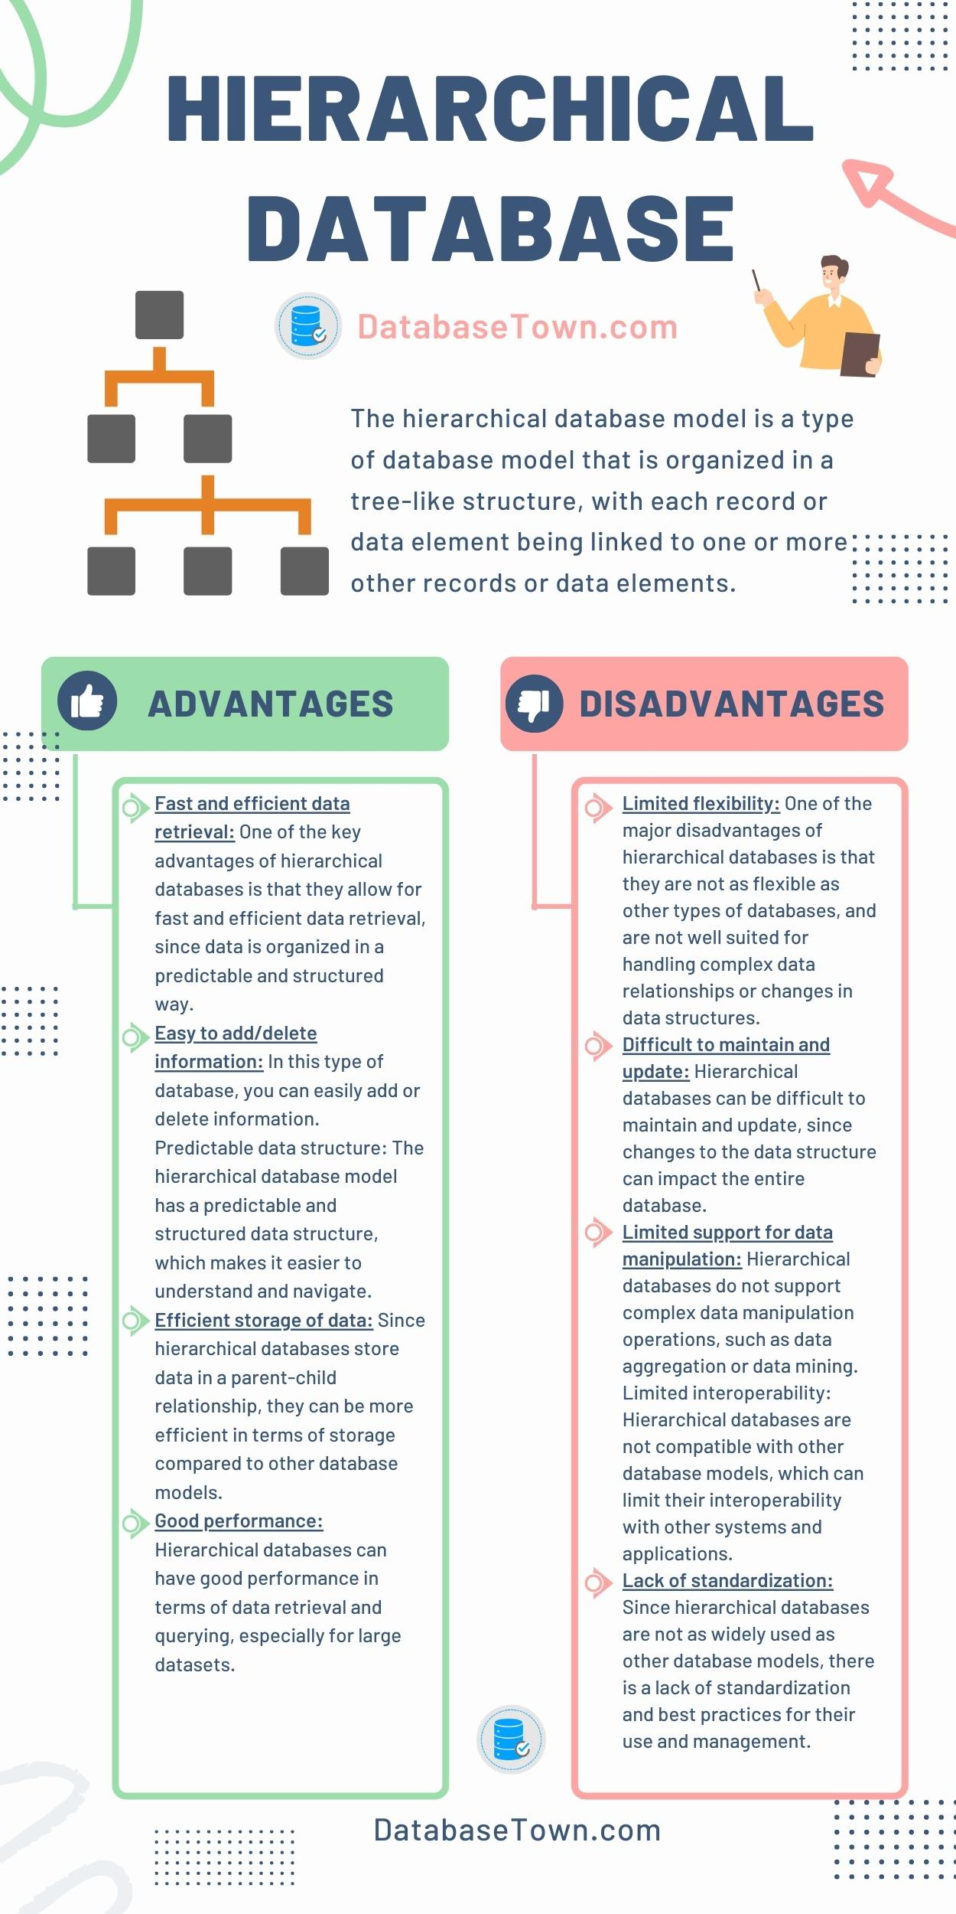Hierarchical Database (Advantages & Disadvantages)
Examples of Hierarchical Data Represented as Relational Tables
An organization could store employee information in a table that contains attributes/columns such as employee number, first name, last name, and department number.
The organization provides each employee with computer hardware as needed, but computer equipment may only be used by the employee to which it is assigned.
The organization could store the computer hardware information in a separate table that includes each part’s serial number, type, and the employee that uses it.
The tables might look like this:
Employee Table
EmpNo | First Name | Last Name | Dept. Num
100 | Almukhtar | Khan | 10-L
101 | Gaurav | Soni | 10-L
102 | Siddhartha | Soni | 20-B
103 | Siddhant | Soni | 20-B
Computer Table
Serial Num | Type | User EmpNo
3009734-4 | Computer | 100
3-23-283742 | Monitor | 100
2-22-723423 | Monitor | 100
232342 | Printer | 100
In this model, the employee data table represents the “parent” part of the hierarchy, whereas the computer table represents the “child” part of the hierarchy.
Each employee may possess several pieces of computer equipment, but each individual piece of computer equipment may have only one employee owner.
Employee Hierarchy Example
EmpNo | Designation | ReportsTo
10 | Director
20 | Senior Manager | 10
30 | Typist | 20
40 | Programmer | 20
In this, the “child” is the same type as the “parent”. The hierarchy stating EmpNo 10 is the boss of 20, and 30 and 40 each report to 20 is represented by the “ReportsTo” column.
In relational database terms, the ReportsTo column is a foreign key referencing the EmpNo column. If the “child” data type were different, it would be in a different table, but there would still be a foreign key referencing the EmpNo column of the employees table.
Hierarchical Databases VS Other Database Models
A hierarchical database model is a type of database model in which the data is organized into a tree-like structure, with a single root node at the top and branches representing different levels of data. Each level of the hierarchy is represented by a table, with the rows representing records and the columns representing fields.
In a hierarchical database model, each record has a single parent record, except for the root node, which has no parent. This means that each record can have multiple child records, but a child record can only have one parent.
A relational database model, on the other hand, is a type of database model in which data is organized into tables that are related to each other through the use of common fields. In a relational database, each table contains a set of records, and the fields in each record represent different attributes of the data.
One of the main advantages of a relational database is that it allows for the creation of complex relationships between different data sets, which is not possible in a hierarchical database. The relational databases are generally more flexible and easier to use than hierarchical databases, as they allow creation of more complex queries and the integration of data from multiple tables.
The following table contrasts hierarchical databases with relational databases and NoSQL databases:
Database Model | Hierarchical Databases | Relational Databases | NoSQL Databases
Flexibility | Limited | High | High
Relationship Support | Parent-child only | Complex relationships | Varies
Performance Efficiency | High | Varies | Varies
Scalability | Limited | Varies | High
Use Cases | File systems,  organizational  structures | Wide  range of  applications | Large-scale,  unstructured data
In contrast to relational databases and NoSQL databases, hierarchical databases are a more common database model. Although hierarchical databases excel in particular use cases, it’s crucial to comprehend their differences:
- Relational databases: Better suited for applications that depend upon rapidly changing data because they provide more flexibility and support complex relationships. However, some use cases that hierarchical databases may handle effectively cause relational databases to experience performance overheads.
- NoSQL databases: Offer scalability and flexibility but may be more complex than hierarchical databases depending on the situation.
Use Cases of Hierarchical Databases
Hierarchical databases is used in different specialized applications due to their ability to efficiently manage structured data with parent-child relationships.
Here are the most common use cases of hierarchical databases.
1. Inventory Management Systems
Hierarchical databases are ideal for inventory management systems because of their structured approach to organizing data. Each inventory item can be represented as a node in the hierarchy, with categories and subcategories forming the parent nodes.
This allows efficient tracking of items, quantities, locations, and other relevant information.
For example, a company might use a hierarchical database to manage warehouse stock, with categories for different types of products and subcategories for individual items.
2. Financial Record-Keeping
Financial data is inherently hierarchical due to which hierarchical databases well-suited for this purpose. Accounts can be organized in a tree-like structure, with each account containing multiple transaction records as child nodes.
This structure facilitates efficient storage and retrieval of transaction histories, account balances, and other financial details. Banks and financial institutions often use hierarchical databases to manage customer accounts, loan records, and transaction data.
3. Network Management Systems
Hierarchical databases are used to store and manage information about network topologies, such as routing tables and network device configurations.
The hierarchical structure mirrors the physical and logical arrangement of network components, making it easy to navigate and manage the network.
For example, a telecommunications company might use a hierarchical database to track the hierarchy of network devices, connections, and their configurations.
4. Geographic Information Systems (GIS)
Hierarchical databases are effective for managing spatial data and geographic information. They can organize data into layers, with each layer representing different types of geographic features, such as regions, cities, and landmarks.
This structure enables efficient querying and retrieval of geographic data, which is essential for applications like mapping, urban planning, and environmental monitoring.
5. File Systems
Hierarchical databases are frequently used in file systems where files and directories are organized in a tree-like structure. Each directory can contain multiple files and subdirectories, creating a clear and organized structure for data storage.
Operating systems, such as Microsoft Windows utilize hierarchical databases for their registry systems, which store configuration settings and options.
6. Organizational Structures
Hierarchical databases are also well-suited for representing organizational structures, such as company hierarchies.
Each department can be a parent node with employees as child nodes. It helps in easy management and retrieval of information related to organizational roles, reporting relationships, and departmental data.
Human resources departments often use hierarchical databases to manage employee records, job titles, and reporting lines.
7. XML Data Storage
With the advent of XML, hierarchical databases found renewed applications in storing and managing XML data.
XML documents inherently have a hierarchical structure, which fits well with the tree-like model of hierarchical databases.
This is particularly useful in web applications and services where data exchange using XML is common.
8. Healthcare Systems
Healthcare systems often require the management of highly structured data, such as patient records, medical histories, and treatment plans.
Hierarchical databases can efficiently store and organize this information and permits quick retrieval and updates.
For example, a hospital might use a hierarchical database to manage patient records, with each patient node containing child nodes for visits, treatments, and prescriptions.
